Download apache Cassandra zip file 3.8

Set CASSANDRA_HOME path

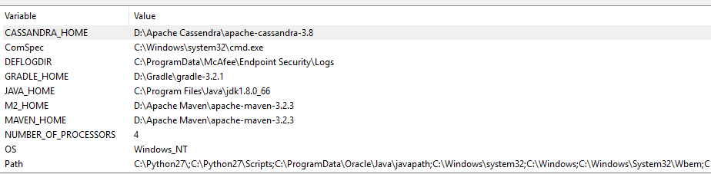

Set Path

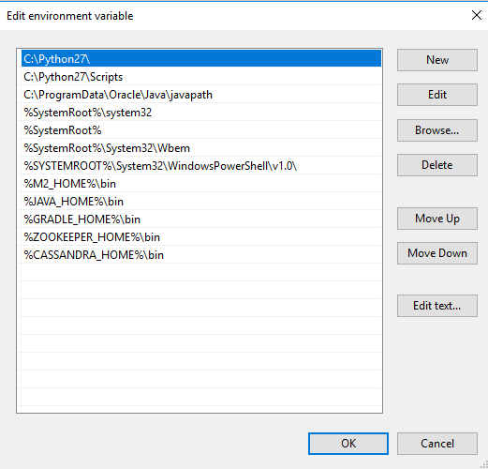

Install python 2

If you are going to use python 3 then cqlsh will not work.

Type Cassandra.bat

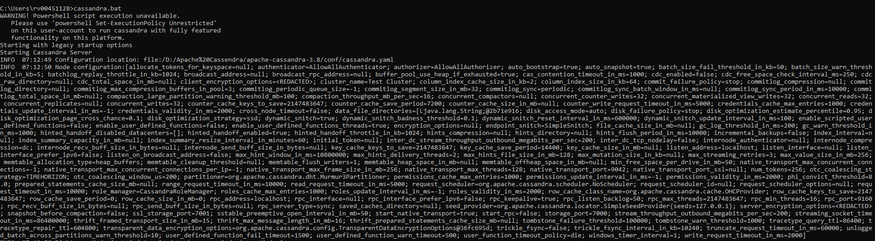

In another window type cqlsh

You are done.